LAB 7: INTERFACES IN JAVA

Name: Shreyas Sawant Div: D7A Roll No.: 55

Q.1 Write a program to define the interface called Matrix. Take the maximum number of rows and columns to be 3 and perform matrix addition and subtraction while implementing the given interfaces.

CODE:

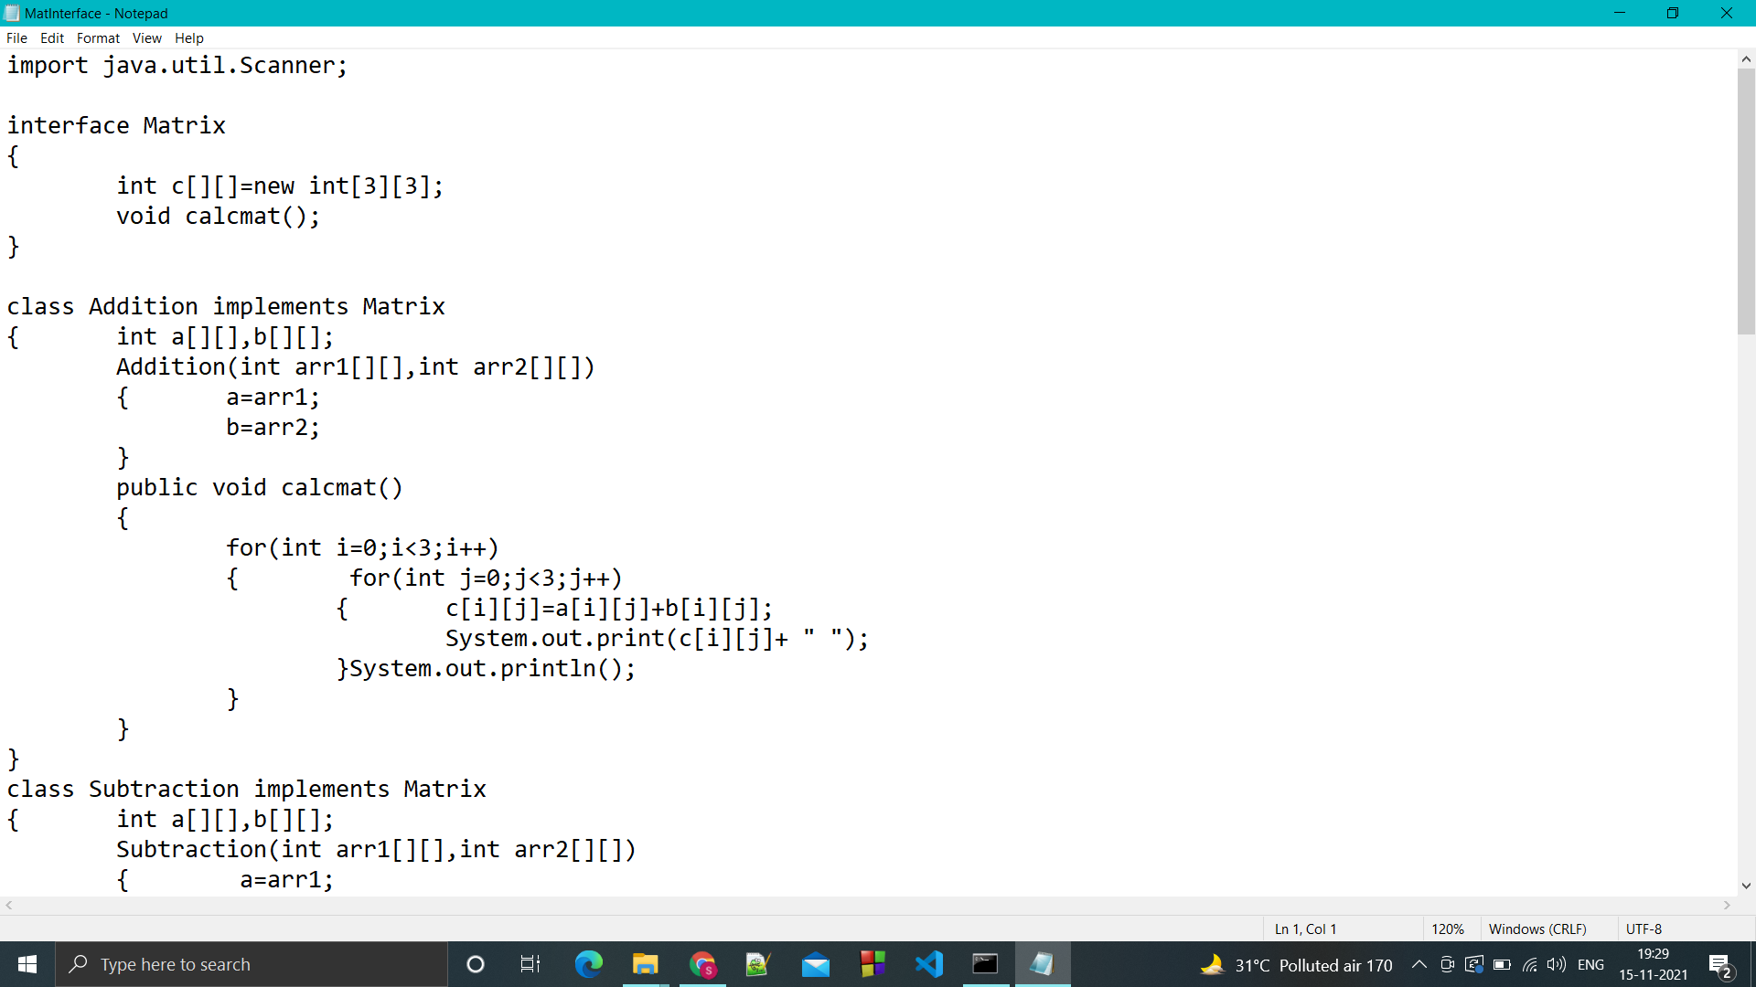

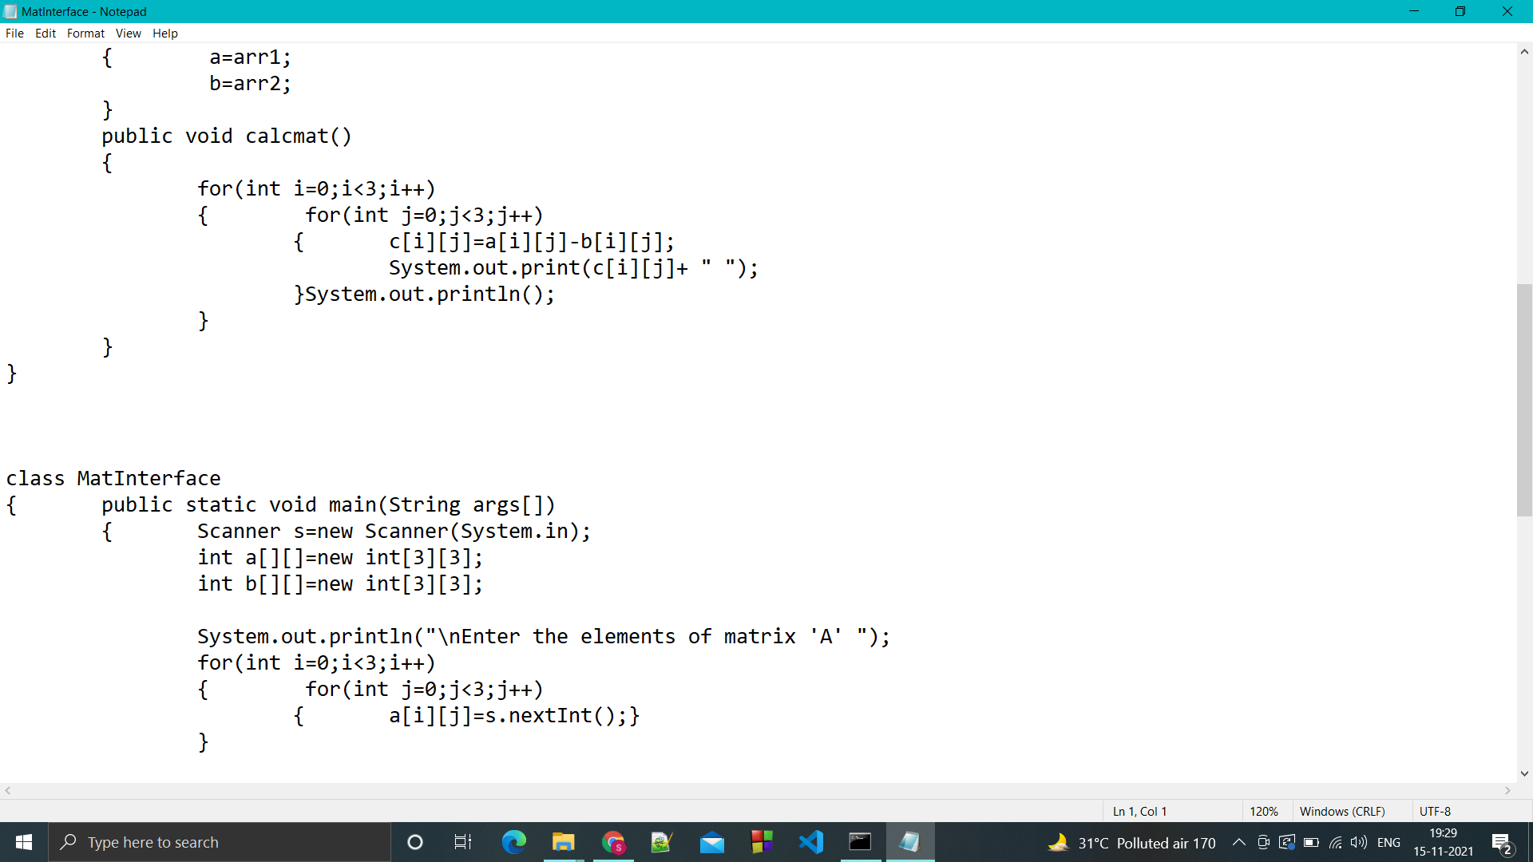

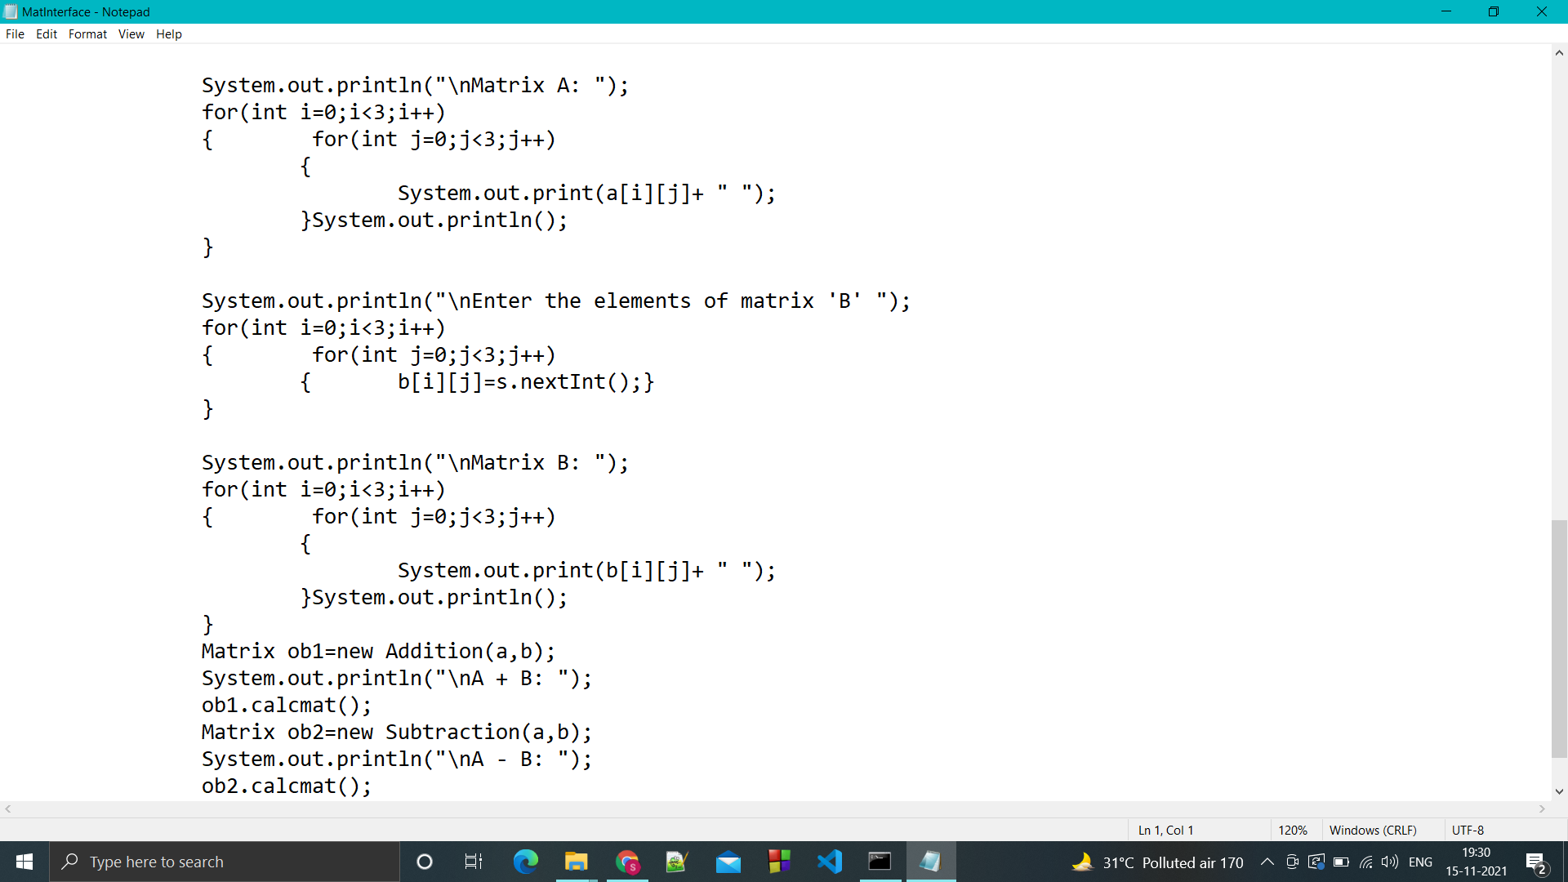

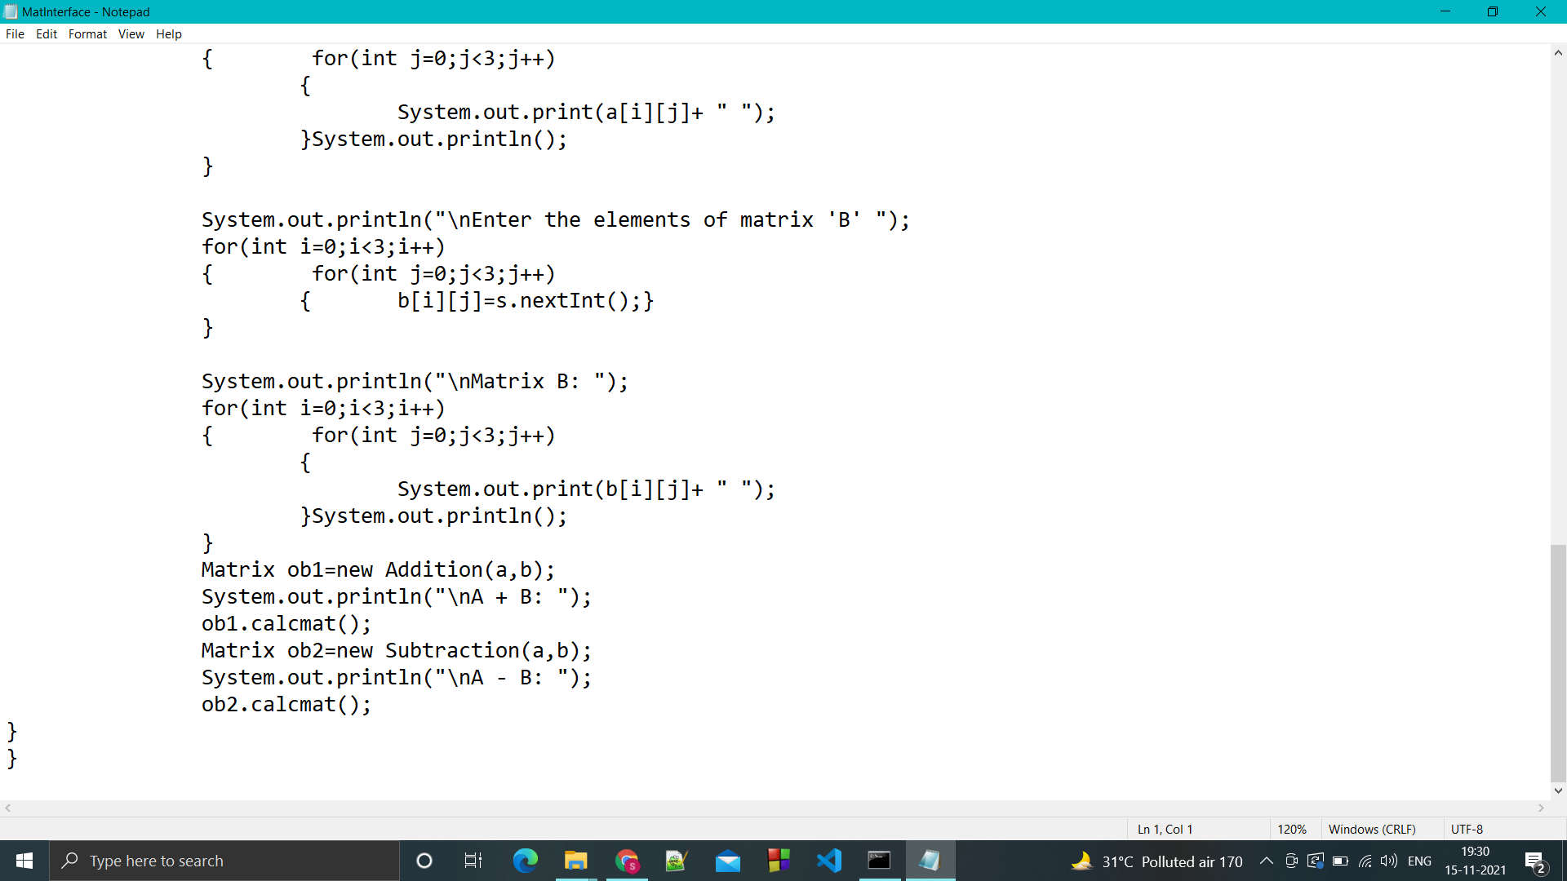

OUTPUT:

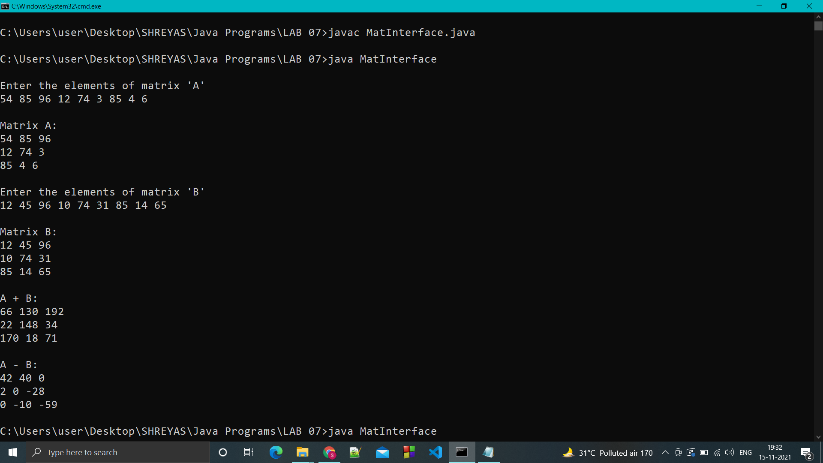

Q.2 Write a program to demonstrate how a class and an interface can be extended and implemented at the same time.

CODE:

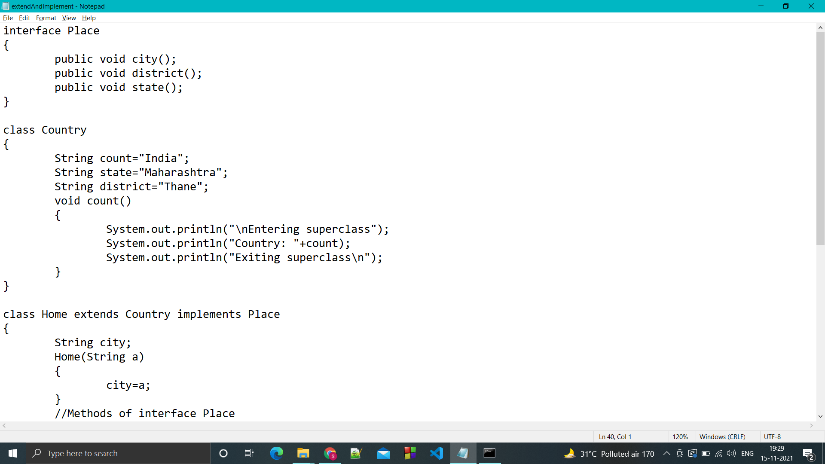

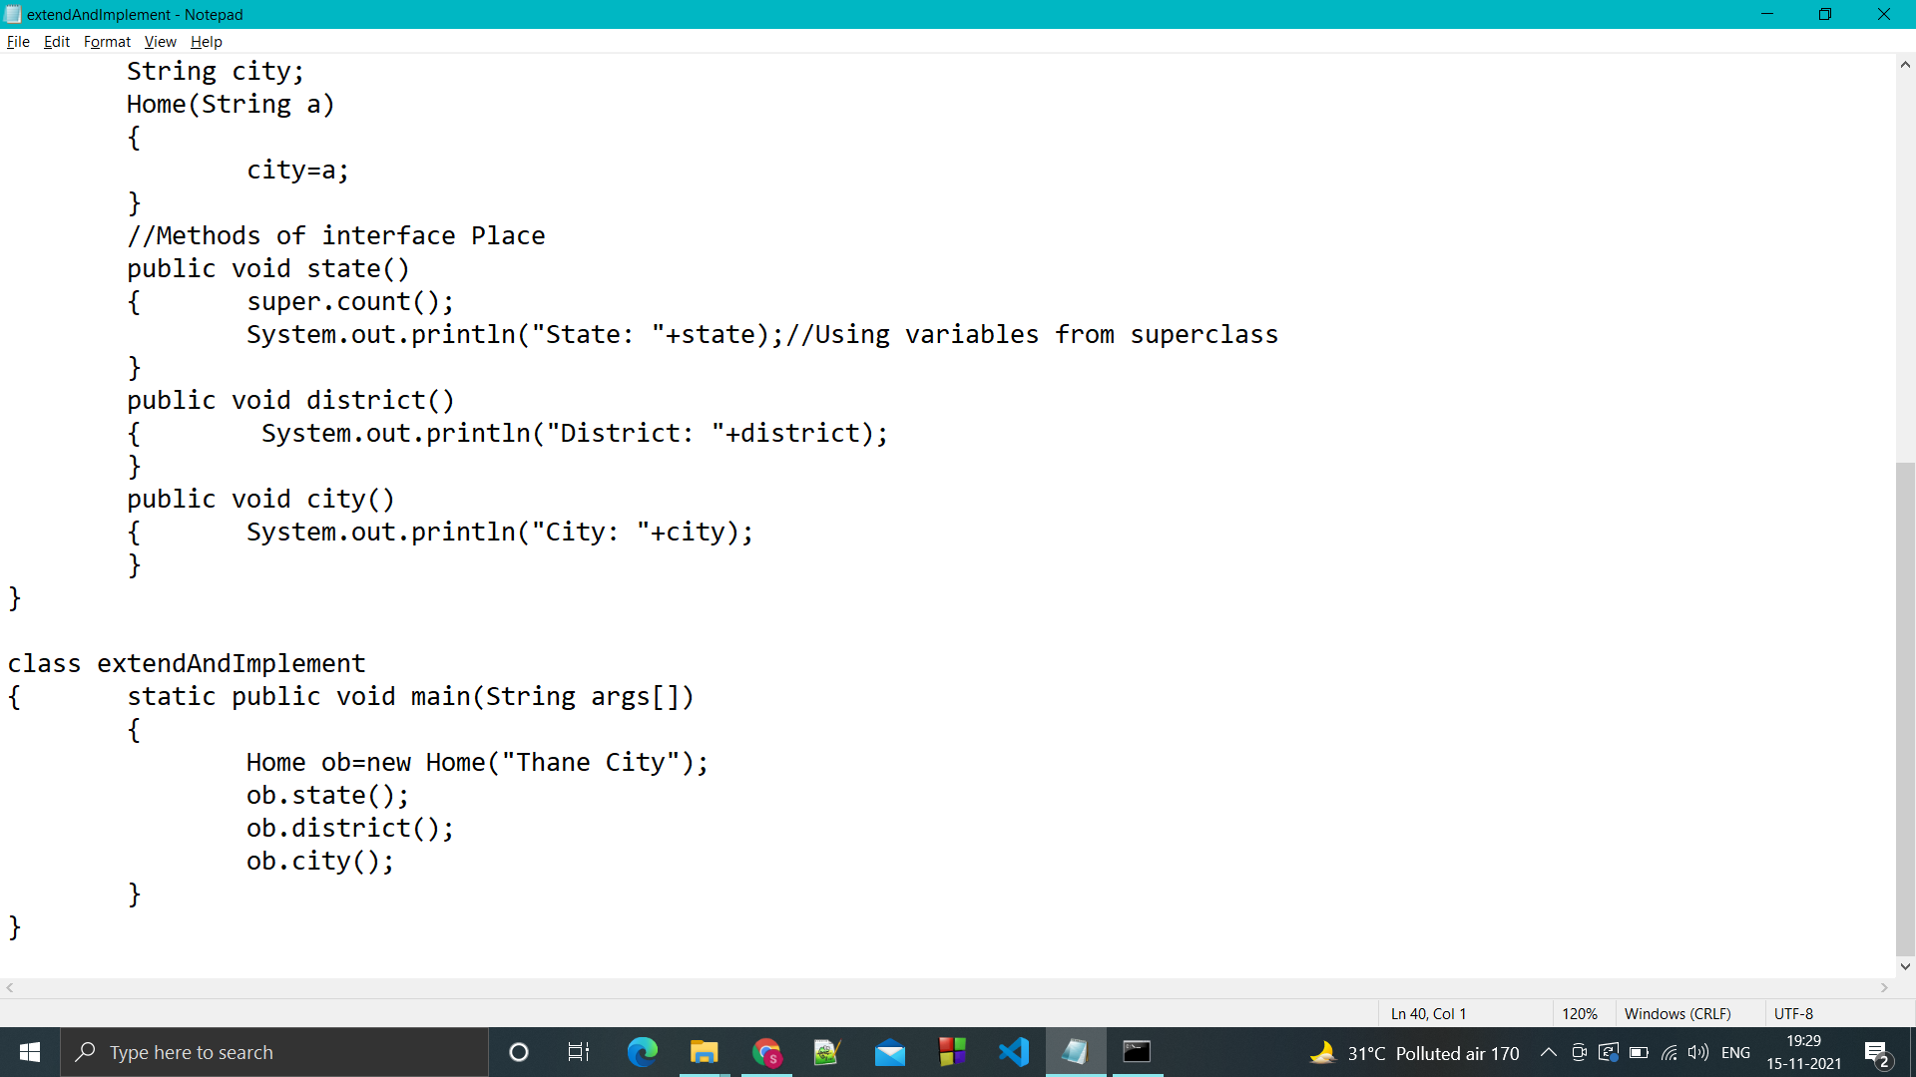

OUTPUT:

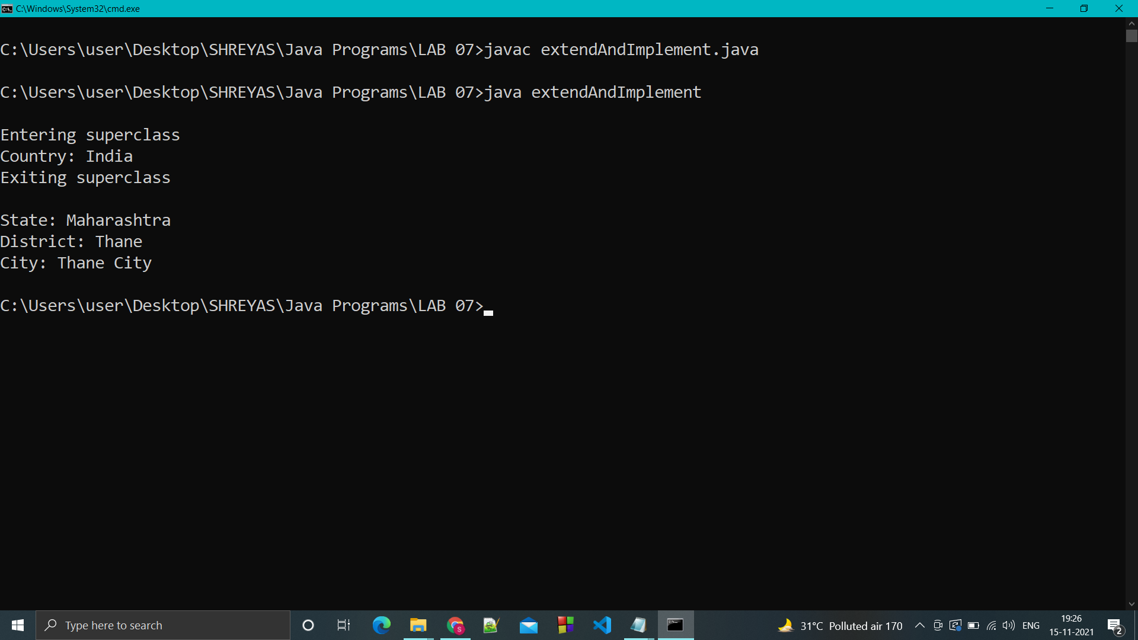

Q.3 Write a program to demonstrate how interfaces can be extended.

CODE:

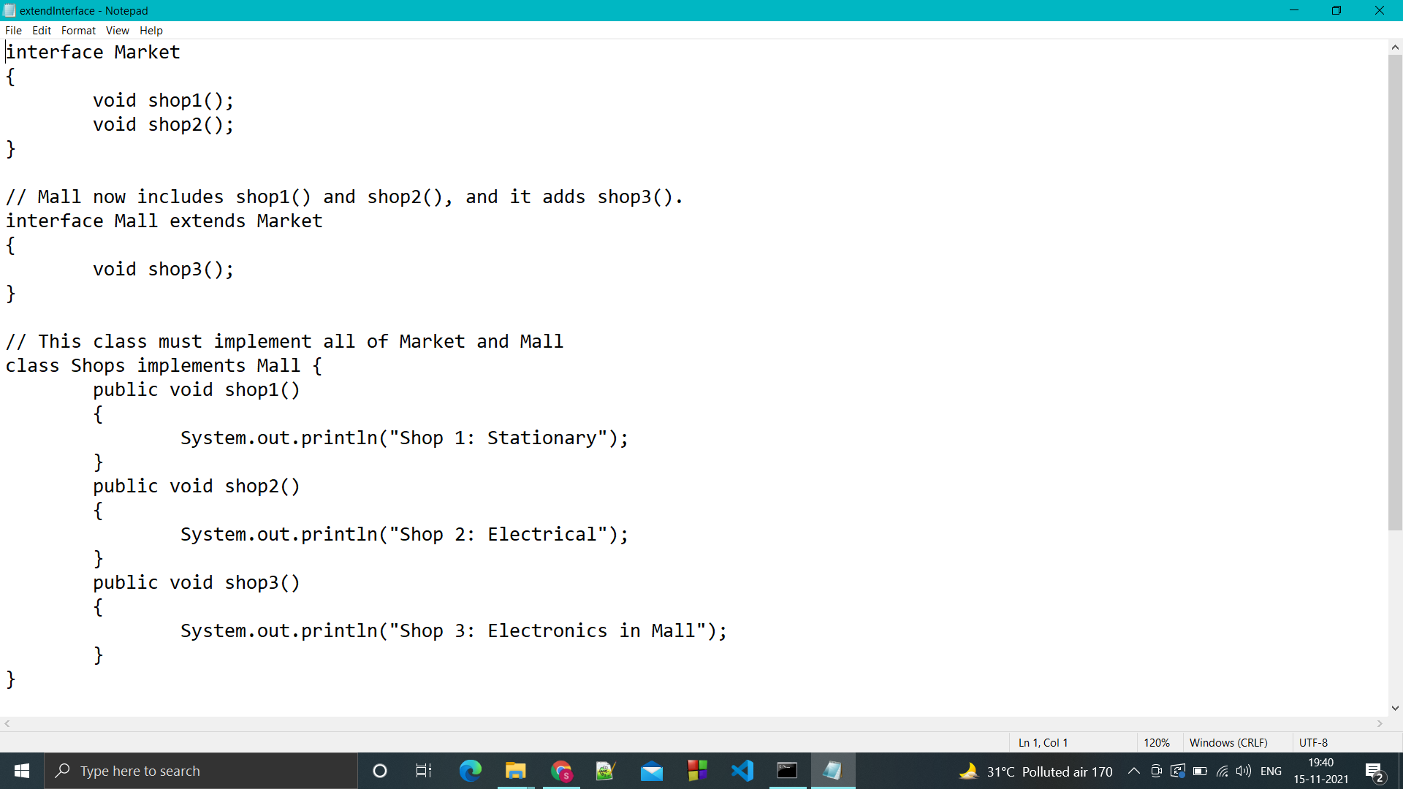

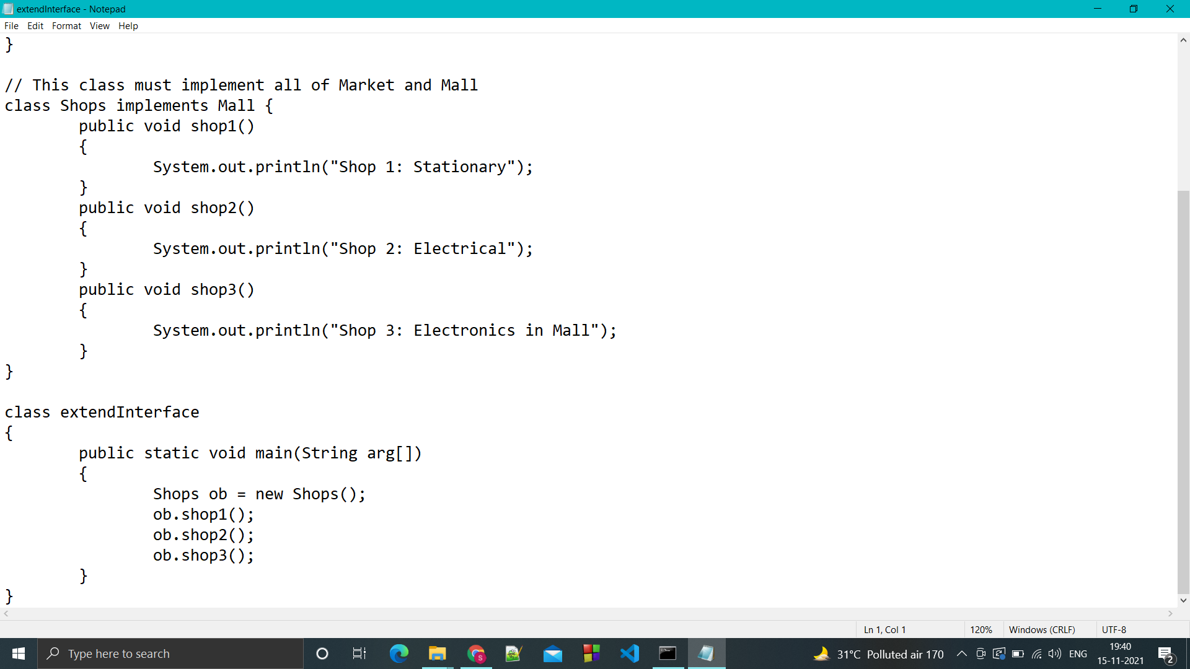

OUTPUT:

